Breaking Democracy

Editor Application Test Plan

**Purpose**

This test plan describes the inner working of the Editor Application for the game Grand Theft Democracy. The Editor Application allows developers to change JSON files in the game to allow for easy changes in game components such as Emails, Events, Situations, and social media posts known as Echoes.

**Features Being Tested**

The document focuses on testing the UI components of the Editor Application. For Unit Tests please see /Edit Components Application/Editor/UnitTests for a list of Unit Tests ran using Visual Studio’s testing suite.

**Initial Testing**

**Test One: Opening the Application**

**1. Click on Editor.exe in the “Edit Components Application” Folder**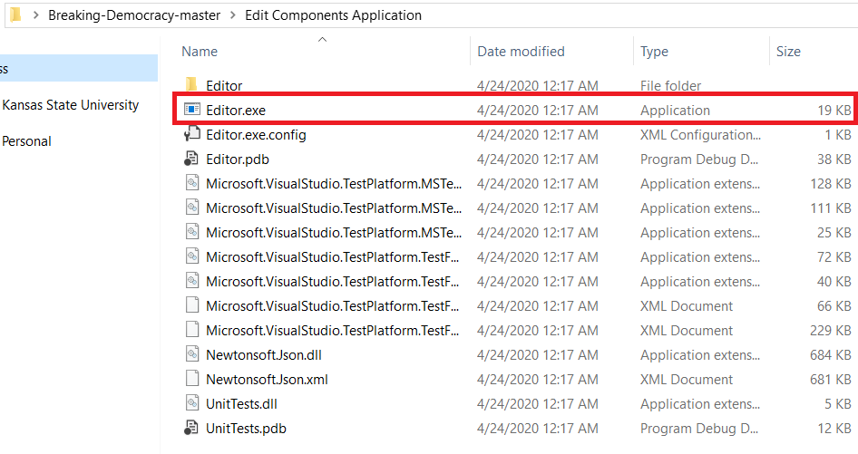

On a successful opening the application will look like this:

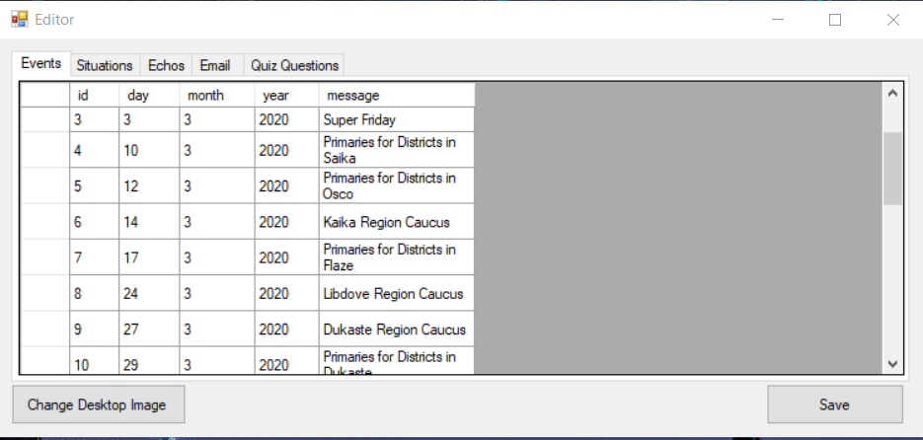

If the application is opened outside of the “Edits Application Folder” the following error message will appear.

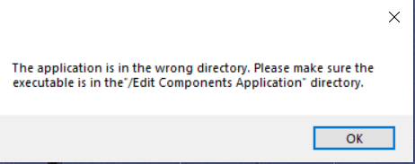

If the JSON files are missing in Grand Theft Democracy the following error will occur.

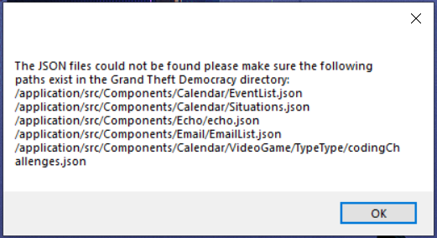

**Test 2: Creating an Entry**

**1. Scroll to the last entry in the Events Tab (The last entry is indicated with a *)**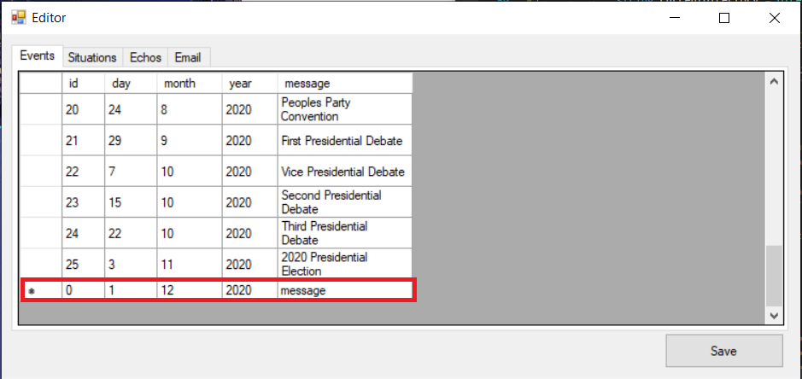

**2. Triple click on the cell marked “0”**

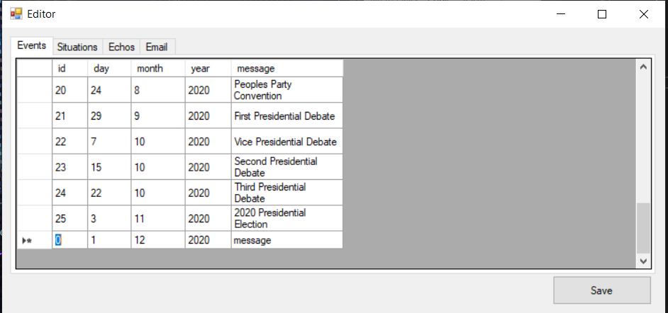

The entry should now be highlighted.

**3. Type “-1” in the cell and push the Tab key**

**4. Type “-1” in the cell and push the Tab key**

**5. Type “-1” in the cell and push the Tab key**

**6. Type “-1” in the cell and push the Tab key**

**7. Type “TEST MESSAGE” in the last cell in the row**

The application should now look like the following: 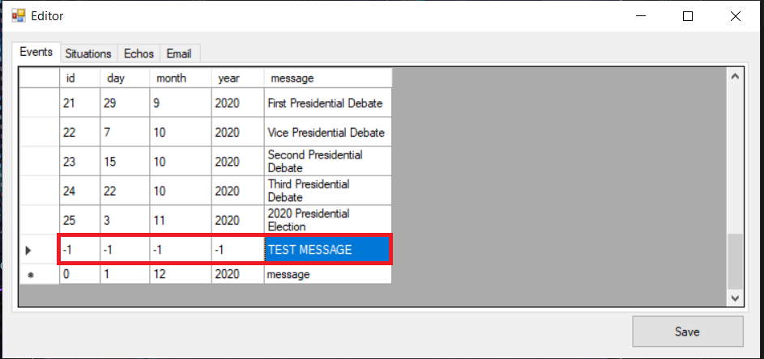

**8. Click the Save Button**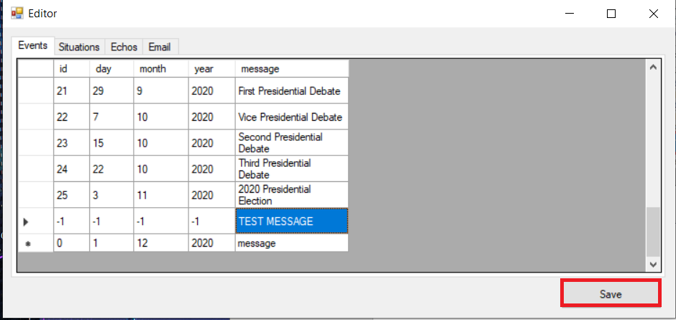

**9. Click the Close Button**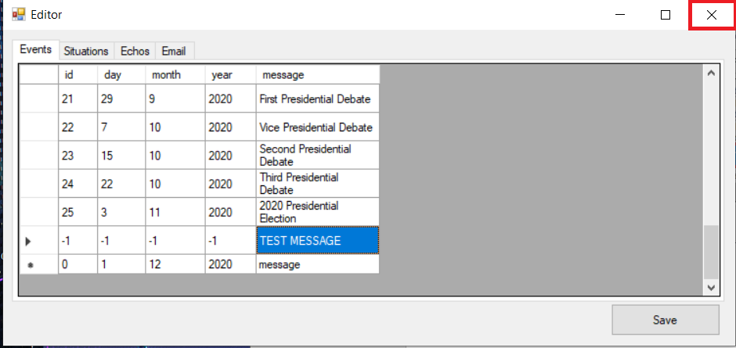

**10. Open the application again**

**11. Scroll to the second to last entry**

**12. Verify the entry “-1” “-1” “-1” “-1” “TEST MESSAGE” is in the second to last row**



If successful, the application has successfully saved the entry to the EventList.json file

If failed, the Save button was not clicked.

**13. Click the arrow to the left of the row you created**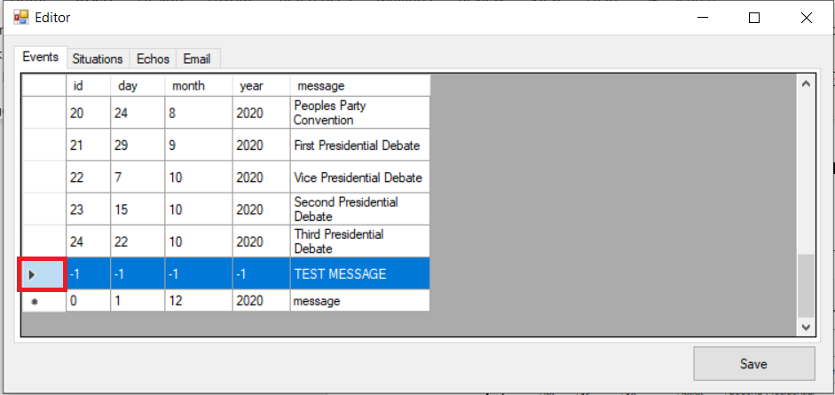

**14. Push the Delete key**

The entry should now be removed from the list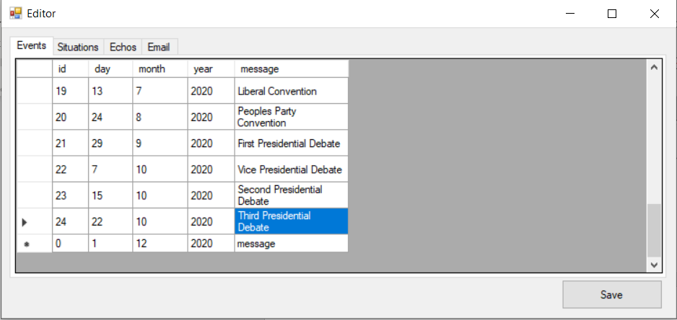

**15. Click the Save Button**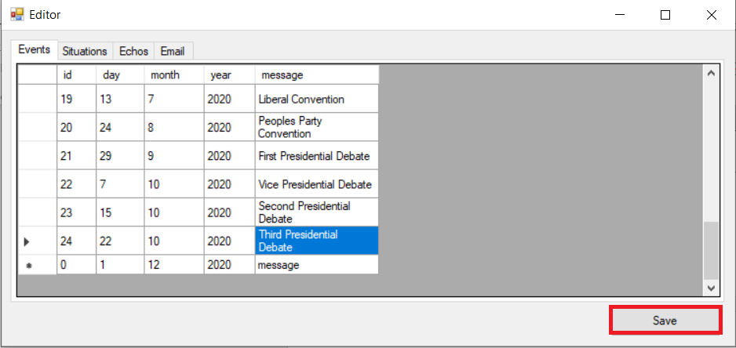

**Test 3: Checking Empty Cells**

**1. Click the Situations Tab**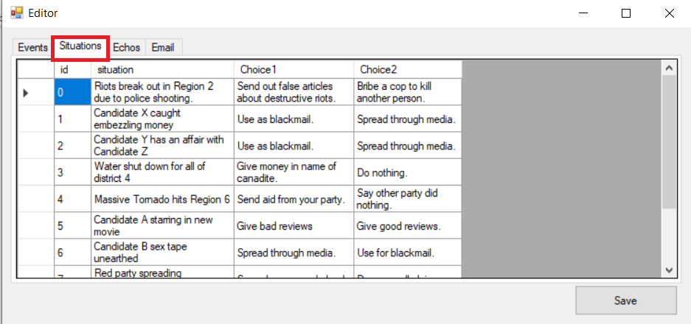

**1. Scroll to the last entry in the Situations Tab (The last entry is indicated with a *)**

**2. Triple click on the cell marked “0”**



The entry should now be highlighted.

**3. Push the Backspace key and then push the Tab Key**

**4. Highlight “situation”**

**5. Push the Backspace key and then push the Tab Key**

**5. Highlight “choice 1”**

**6. Push the Backspace key and then push the Tab Key**

**7. Highlight “choice 2”**

**8. Push the Backspace key and then push the Tab Key**

The application should now look like the following with the second to last line being empty: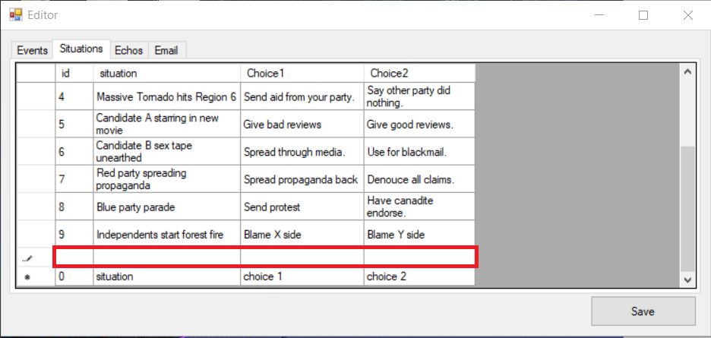

**9. Click the Save Button**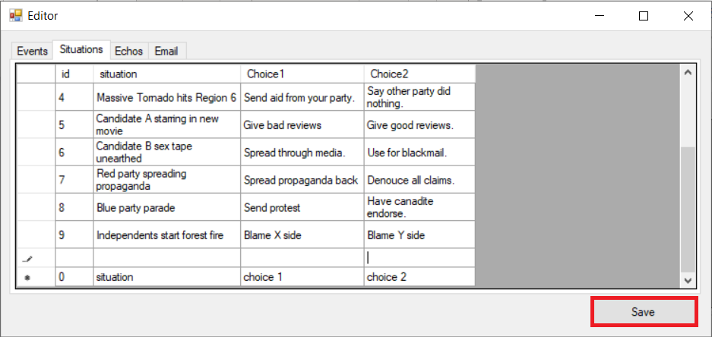

**10. The last two lines should now look exactly the same**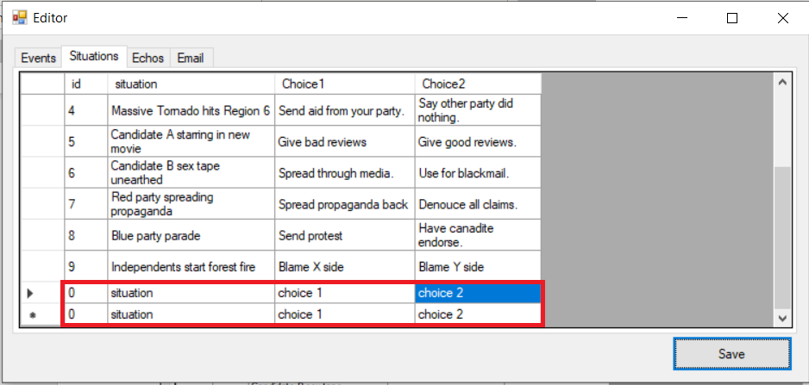

If successful, this means the cells are being updated to the default values when a cell is empty.

If failed, the btnSave_Click method will need to be updated to properly handle null cases. Please read the in-comments in Editor.cs for more information on when null cases are handled.

**11. Click the arrow to the left of the row you created**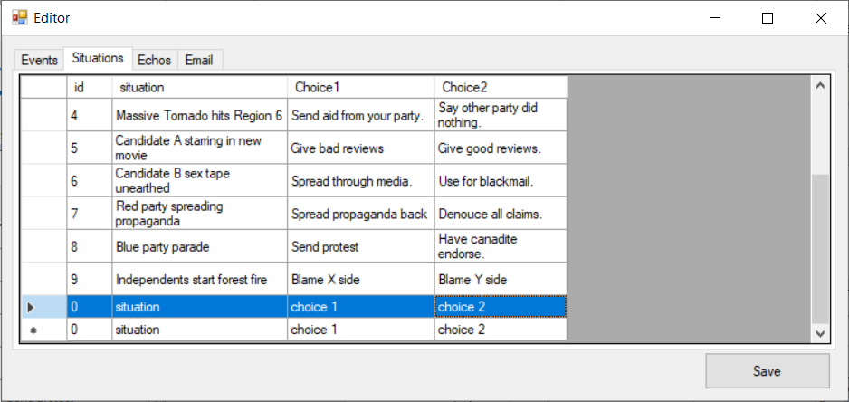

**12. Push the Delete Key**

The application should look similar to the original state of the test.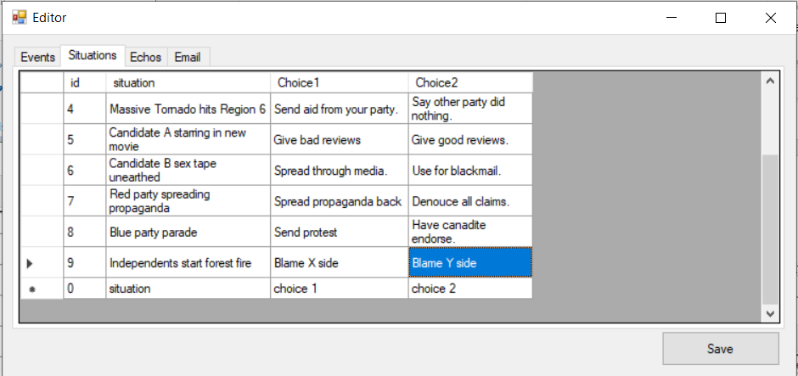

**13. Click the Save Button**